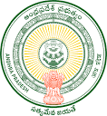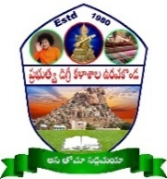**GOVERNMENT DEGREE COLLEGE**

**URAVAKONDA - 515 812**

(Accredited by NAAC with B Grade)

Affiliated to S K. University, Ananthapuramu

**PERSONAL PROFILE**

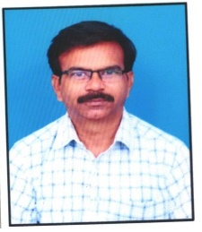

**V. GOPI**

**Contract faculty in Telugu,**

Photo

**Govt. Degree College, Uravakonda**

**email: govivalmiki24@gmail.com**

**Educational Qualifications:**

M.A., M.Ed., T.P.T.

**Professional Experience:**

08 years as B.Ed College Lecture

* Sreedevi College of Education, Borampalli, kalyandurgam (From 01-11-2008 to 30-05-2016)

10 years as DL in Commerce (11-11-2006 to till to date)

* Raghavendra Degree College, Krishanamreddypalli, Cheyyadu Post (From 24-06-2016 to 30-06-2022)
* Govt Degree College, Uravakonda (From 01-08-2022 to till to date)

**Academic Development: (RC, OC, FDP, TOT, MOOCS, Training programmes etc.)**

* Attended 3 days Training Programm on Intrenship and LMS from 02-02-2023 to 04-02-2023 at NRC Govt. Degree College(Auotonomus), Anantapuramu
* Attended 1 day training program UNESCO MGIEP at NRS Govt. Degree College, Guntakal on 25-01-2024

**Administrative Responsibilities:**

* Admistrative Responsibilities – Member
* Cultural Committee – Member
* Languages Association- Member
* Press Public Relationship Committee - Member

**Achievements:**

**Nil**

**Research Publications:**

Nil