GOVT. DEGREE COLLEGE, URAVAKONDA

FRESHER’S DAY CELEBRATIONS

27-17-2017

CHIEF GUEST

PROF. K. VENUGOPALA RAO

DEAN, C.D.C., S.K.UNIVERSITY

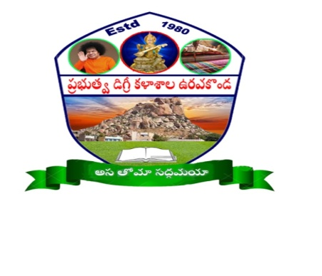GUEST OF HONOUR

PROF. A.SIVA KUMAR

JNTUA, ANANTAPURAMU

STUDENTS, STAFF,C.P.D.C. & PRINCIPAL